
EPI21 News Release
Presentation #69
Embargoed until 10 a.m. CT/ 11 a.m. ET, Thursday, May 20, 2021

Contact Information: Christopher C. Moore, M.S., may be reached at chris_moore@unc.edu (please do not publish contact information).

Session Assignment
06B - Physical Activity (Presentation #: 069 ; Speaking Time: 5/21/2021 12:30:00 PM - 5/21/2021 12:38:00 PM)

Title
Sporadic Step Accumulation And All-cause Mortality In The Women’S Health Study: Do All Steps Count?

Abstract Content
Background: With the popularity of step counting and feasibility of accumulating physical activity (PA) through sporadic spurts (e.g., taking the stairs), the 2018 PA Guidelines Committee called for research to inform step-based PA recommendations by quantifying relationships between patterns of stepping and health. Purpose: To examine the relationship between daily steps accumulated outside of “bouts” (sporadic steps/d) and all-cause mortality, before and after accounting for bouted steps/d. Methods: From 2011-2015, 16,732 women (mean 72 [standard deviation 6] years) wore a hip-worn accelerometer for 7 days to assess steps and met wear time criteria. Stepping bouts were defined as ≥10 consecutive minutes at ≥40 steps/min (purposeful stepping or faster), allowing for ≤20% of time and ≤5 mins at <40 steps/min. Total steps/d were partitioned into steps accrued outside of bouts (sporadic steps/d; SS) and in bouts (bouted steps/d; BS). We estimated hazard ratios (HRs) for mortality through Dec 31, 2019 using Cox proportional hazard models fitted to SS in quartiles and using restricted cubic splines. Analyses were adjusted for covariates and repeated with further adjustment for BS, categorized as 0, 1-2000, and >2000 steps/d in bouts. Results: Adjusted HRs (95% confidence intervals) in increasing quartiles of SS were 1.00 (reference); 0.63 (0.52, 0.76); 0.60 (0.49, 0.74); 0.54 (0.42, 0.70). In spline analyses, initial increases in SS corresponded to the greatest mortality reductions (Figure 1), with HRs of 0.69 (0.64, 0.76) per additional 1000 SS below 3200. After further adjusting for BS, initial 1000 steps/d increases in SS were association with HRs of 0.72 (0.66, 0.78). In increasing categories of BS, HRs adjusted for SS were 1.00 (reference); 0.91 (0.76, 1.09); 0.69 (0.56, 0.84). Conclusion: Daily step counts were inversely associated with mortality, regardless of how they were accumulated. These results can help inform step-based target PA volumes that communicate the benefits of increasing everyday walking behaviors.
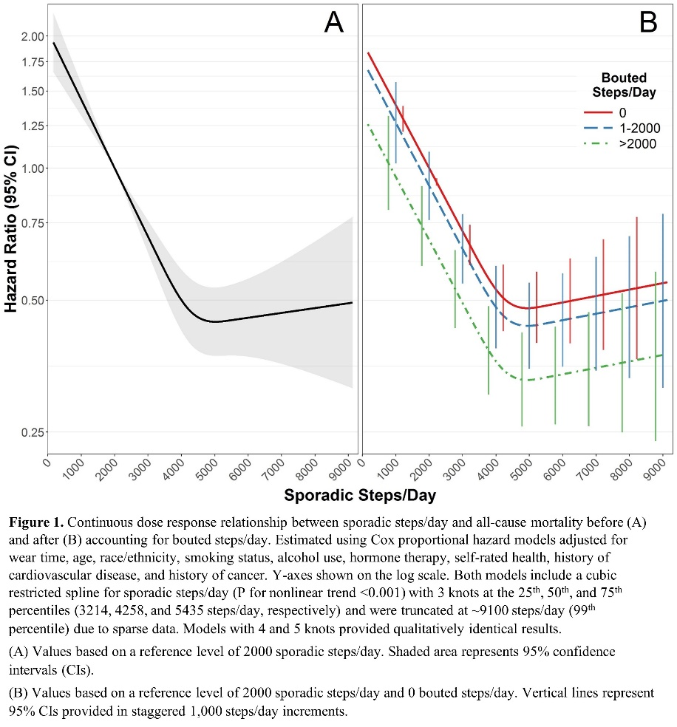

Author Block
Christopher C Moore, Kelly R Evenson, Univ of North Carolina at Chapel Hill, Chapel Hill, NC; Eric J Shiroma Jr., Natl Inst on Aging, Bethesda, MD; Annie G Howard, Carmen C Cuthbertson, Univ of North Carolina at Chapel Hill, Chapel Hill, NC; Julie E Buring, I-Min Lee, Harvard Univ, Boston, MA

