
Daniel Armbruster
Public Affairs
AAA Texas/New Mexico
armbruster.daniel@ace.aaa.com
Cell: 512-564-3141

Doug Shupe
Public Affairs
AAA Texas/New Mexico
shupe.doug@ace.aaa.com
Cell: 512-659-1632

For Immediate Release: October 5, 2023

AAA Texas: Gas Prices on Downward Trend as Demand for Fuel Sinks
(Coppell, TX) – The statewide gas price average in Texas is $3.30 for a gallon of regular unleaded fuel, according to the AAA Texas Weekend Gas Watch. That price is eight cents less than on this day last week and is 15 cents more per gallon compared to this day last year. Of the major metropolitan areas surveyed in Texas, drivers in El Paso are paying the most on average at $3.58 per gallon while drivers in Abilene are paying the least at $3.13 per gallon. The national average price for a gallon of regular unleaded is $3.77, which is six cents less when compared to this day last week and six cents less than the price per gallon at this same time last year.
For the third consecutive week, the average gas price across the state has dropped. Recent data from the Energy Information Administration (EIA) reveals that there has been a notable decrease in gasoline demand. On Wednesday, the price of crude oil plummeted by more than $5 per barrel, prompted by the news of declining fuel demand. It's important to note that crude oil is the primary component of gasoline. If crude oil prices remain lower, it is likely that retail fuel prices will continue to decrease. Additionally, the current shift to winter-blend gasoline will further contribute to lowering pump prices.
"Reduced fuel demand, falling crude oil prices, and the transition to cheaper winter-blend gasoline are all factors pushing down retail gasoline prices,” said Daniel Armbruster, AAA Texas spokesperson. “With the arrival of cooler weather, we want to remind drivers that October is National Car Care Month. Maintaining a healthy vehicle not only lowers the risk of breakdowns but is also crucial for maximizing fuel efficiency."

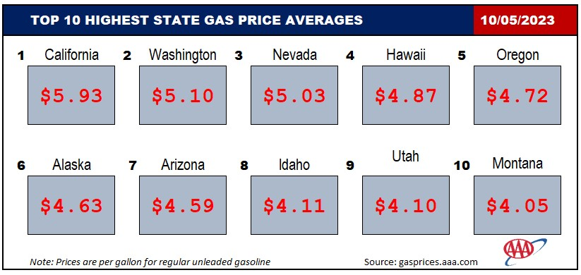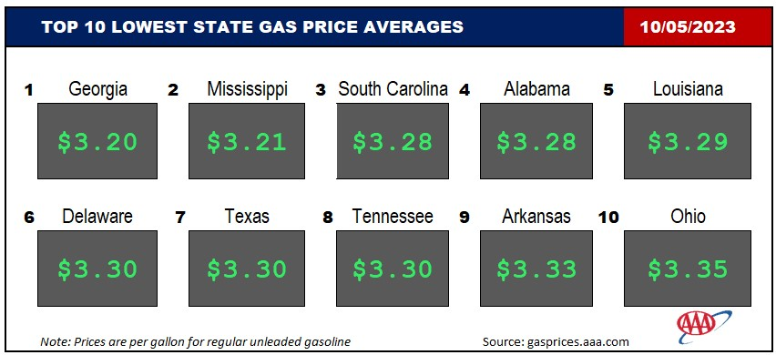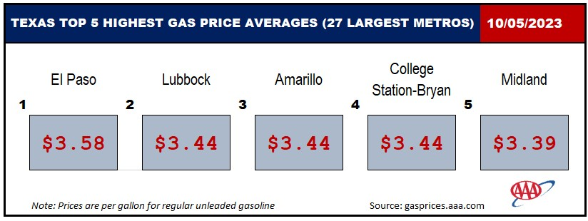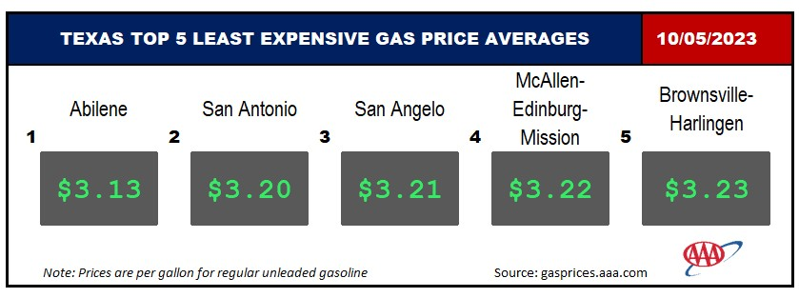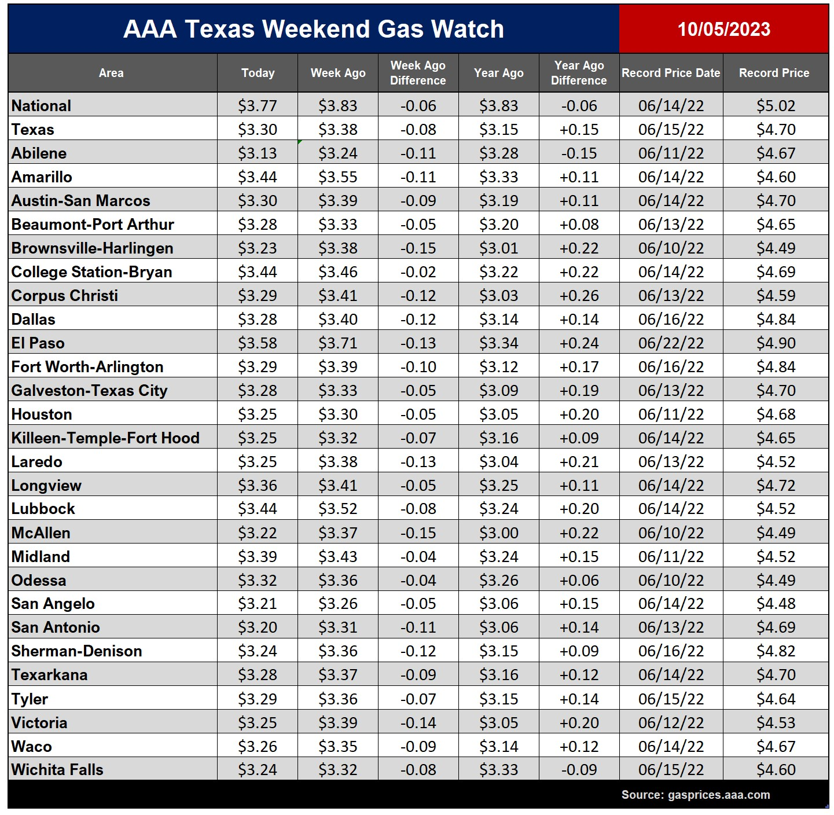

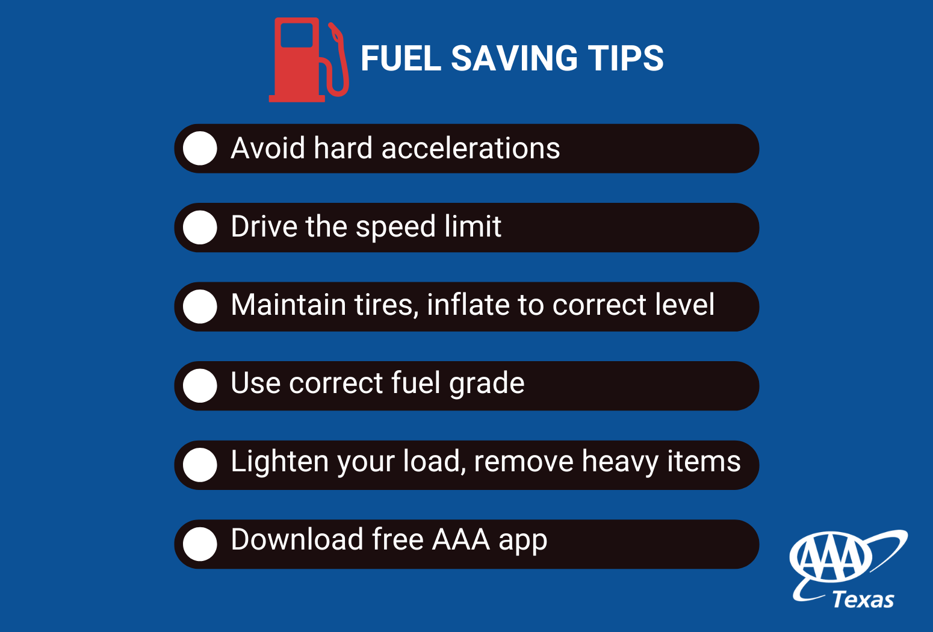

Drivers in Texas are paying the seventh lowest gas price average in the country, according to gasprices.aaa.com. Meanwhile, drivers in California are paying the most at $5.93 on average for a gallon of regular unleaded.

Prices up to date at press time using market prices posted at 3:41 a.m. Motorists can find current gas prices along their route with the free and revamped AAA App for iPhone, iPad and Android. The app can also be used to map a route and learn traffic conditions along that route, find discounts, locate parking, book a hotel and request and track AAA roadside assistance. Learn more at www.AAA.com/mobile.

###

