
Daniel Armbruster
Public Affairs
AAA Texas/New Mexico
armbruster.daniel@aaa-texas.com
Cell: 512-564-3141
Twitter: @AAATexas

Joshua Zuber
Public Affairs
AAA Texas/New Mexico
zuber.joshua@aaa-texas.com
Cell: 713-533-2946
Twitter: @AAATexas

For Immediate Release: April 29, 2021

AAA Texas: Statewide Gas Price Average Down a Penny as Demand Drops Slightly, Supply Increases

(Coppell, TX) – The statewide gas price average in Texas is $2.58 for a gallon of regular unleaded fuel, according to the AAA Texas Weekend Gas Watch. That price is one cent less than on this day last week and is $1.07 more per gallon compared to this day last year. Of the major metropolitan areas surveyed in Texas, drivers in El Paso are paying the most on average at $2.89 while drivers in San Antonio are paying the least at $2.40 per gallon. The national average price for a gallon of regular unleaded is $2.89, which is one cent more when compared to this day last week and $1.12 more than the price per gallon at this same time last year.
According to the latest data from the Energy Information Administration, demand for U.S. gasoline dropped back below nine million barrels per day, which was a decline of two percent week-to-week. Regional fuel supplies increased, and Gulf Coast refinery utilization registered higher as well, increasing slightly to 90 percent. Crude oil prices have also been on the rise, sitting at $65 per barrel for West Texas Intermediate (WTI), Thursday morning.
“Texas drivers are seeing some stability at the pump when compared to last week,” said AAA Texas spokesperson Daniel Armbruster. “However, market forecasts still suggest that prices will likely rise as we head into the summer driving season, but by how much remains to be seen.”
Drivers in Texas are paying some of the cheapest gas prices in the U.S., with the 2nd lowest statewide average in the country, according to gasprices.aaa.com.
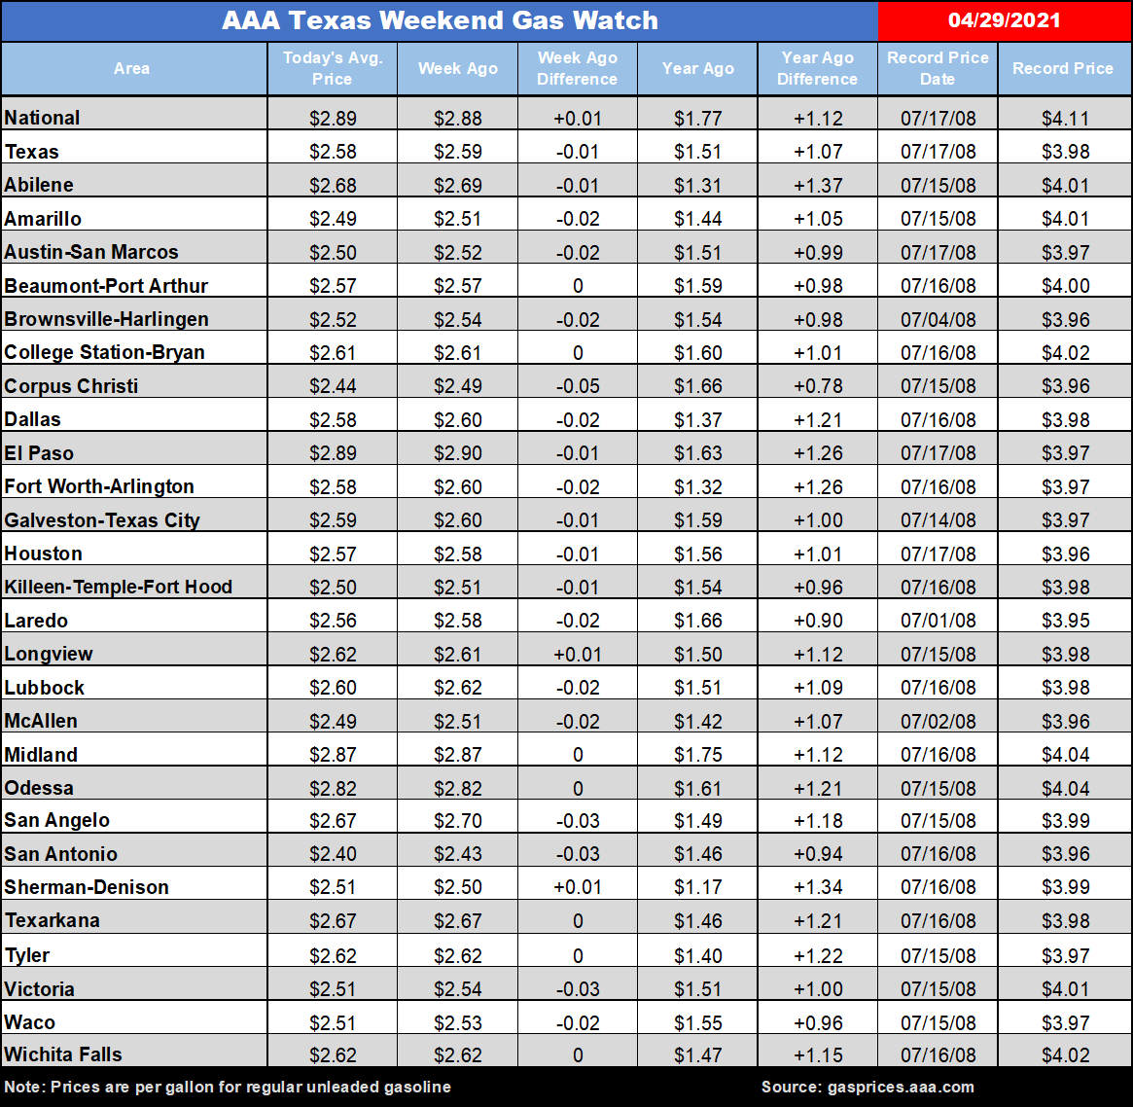
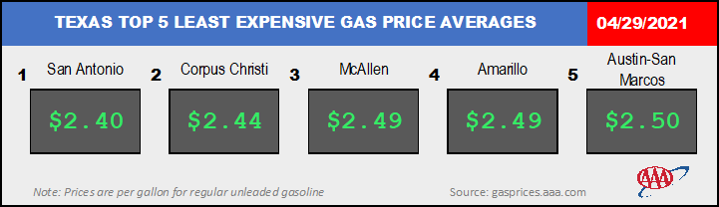
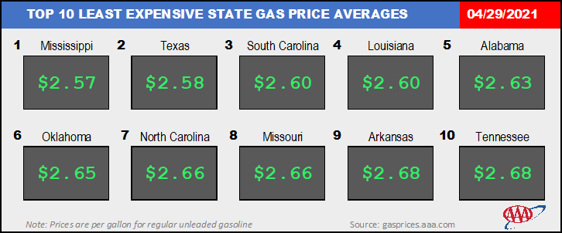
Prices up to date at press time using market prices posted at 3:41 a.m. Motorists can find current gas prices along their route with the free and revamped AAA App for iPhone, iPad and Android. The app can also be used to map a route and learn traffic conditions along that route, find discounts, locate parking, book a hotel and request and track AAA roadside assistance. Learn more at www.AAA.com/mobile.
To help members and non-members identify quality auto repair shops that can assist in the maintenance and repair of their vehicles, AAA offers the Approved Auto Repair program as a free public service. AAA-approved repair facilities meet and maintain high professional standards for training, equipment, cleanliness and customer service. Motorists can look for the Approved Auto Repair sign at local auto repair facilities, or search for a nearby AAA-approved shop online at AAA.com/Repair. AAA Texas branch offices throughout the state can be found by visiting www.AAA.com. Follow AAA Texas on Twitter: @AAATexas and Facebook: www.facebook.com/AAATexas.

###

